Alec D’Angelo

<https://worditout.com/word-cloud/4982887/private/f0c47d2e1dffa8a9c4c3ef5d836fd366>

The non-profit Unicorn Riot compiled a list of 75 online posts from individuals detailing their respective conversions to fascism.

An analysis of these posts reveals common themes and words cited in describing their radicalization.

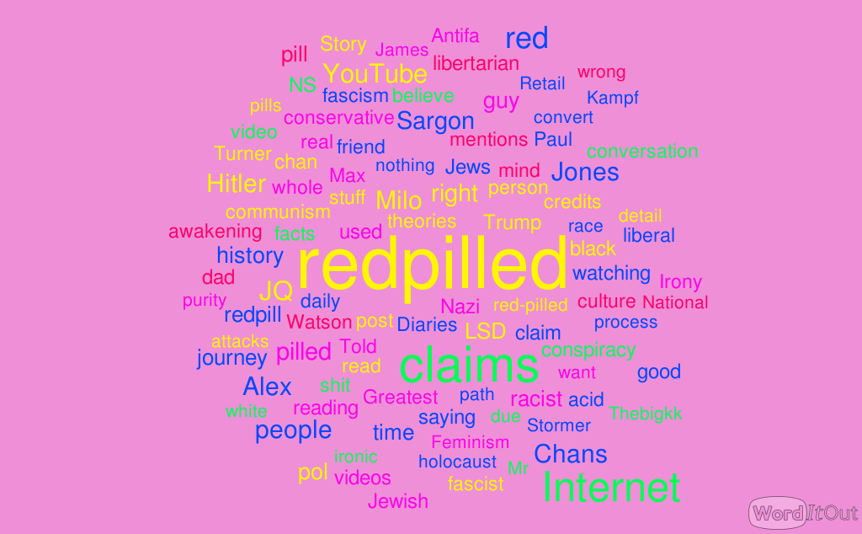

Of interest is the prominence of names like Milo, Alex(Jones), Sargon and Watson. This highlights the prevalence of alt-right internet influencers in radicalizing users online. Equally interesting is the prevalence of friend, convert and dad, showcasing how fascists recall being radicalized by peers, friends or even family. The prevalence of Youtube, POl, Chans and video reveal the intersection of these influences on social media. This indicates that social forces, particularly online in the form of parasocial relationships with alt-right influencers, play a large role in political radicalization.